* 1. 

Hands-On Lab

Building Applications in Silverlight 4

ASP.NET Web Forms Application to Silverlight

**Contents**

Lab 2: Migrating an ASP.NET Web Forms Application to Silverlight 3

Exercise 1: Exploring an ASP.NET Web Forms Application 6

Exercise 2: Migrating an ASP.NET Application to Silverlight 10

Exercise 3: Calling a WCF Service and Binding Data 18

Summary 26

Lab 2: Migrating an ASP.NET Web Forms Application to Silverlight

Silverlight provides a Rich Internet Application (RIA) framework that can be used to build applications that can be deployed through the Web while preserving the rich client-side functionality found in traditional desktop applications. This lab is designed to guide ASP.NET and jQuery developers through the process of migrating applications to Silverlight.

* 1. In the lab you'll convert an existing ASP.NET/jQuery application that consumes data from a Windows Communication Foundation (WCF) service to Silverlight and ensure that existing functionality is preserved. Along the way you'll learn how to create a Silverlight user interface, handle events, make asynchronous calls to services, bind data to controls, plus more.
  2. You'll start by researching existing data access and WCF service projects used by an ASP.NET application. Next, you'll run the ASP.NET application to see the feature set that will be migrated to Silverlight. To accomplish the migration you'll create a new Silverlight project in Visual Studio 2010 and use eXtensible Application Markup Language (XAML) along with managed code (both C# and VB are supported in the lab). The Silverlight application that you'll create is shown next:
     1. 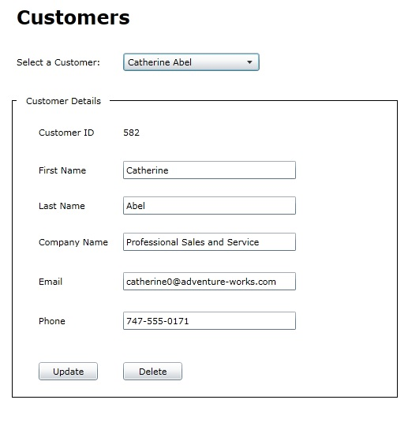
     2. Figure 1
     3. Customer Details

#### You Will Benefit from this Lab if:

* + You are migrating an ASP.NET Web Forms application to Silverlight
  + You'd like to create a rich-client application that takes advantage of a web-deployment model
  + You need to integrate distributed data into an application

#### You Will Learn:

* + How to use the Visual Studio 2010 Silverlight Designer
  + XAML and Silverlight control concepts
  + How WCF services can be integrated into Silverlight applications
  + Silverlight data binding techniques
  + How to make asynchronous calls to services
* How to work with cross-domain services
* Similarities between ASP.NET and Silverlight applications

#### Business Requirements for the Silverlight application include:

* Create a new Silverlight project and associated ASP.NET Web Application project
* Re-use existing data access and WCF service code
* Use XAML to define the user interface and emulate the ASP.NET application
* Handle user interface events
* Create a WCF service proxy
* Call the WCF service using the asynchronous programming model
* Bind data to controls using Silverlight binding syntax
* Handle update and delete operations and notify the user about the status of the operation

Exercise 1: Exploring an ASP.NET Web Forms Application

* 1. Estimated Time: 45 minutes
  2. In this exercise you'll open an existing Visual Studio 2010 solution and walk through code found in a WCF and ASP.NET project. The main goal of the exercise is to get acquainted with an existing ASP.NET application and supporting code to better understand what code can be re-used during the migration to Silverlight. Throughout the exercise you'll view data access code that relies on Entity Framework 4, examine a WCF service contract and run the ASP.NET project to explore the functionality it offers. To get started, follow the steps below.
  3. Open Visual Studio 2010 and then select **File 🡪 Open Project/Solution** from the menu.
  4. Open the following Visual Studio solution file:

|  |  |
| --- | --- |
| Language | Lab Files Location |
| C# | /MigratingToSilverlight/Starting Point/C#/CustomerViewer/CustomerViewer.sln |
| Visual Basic | /MigratingToSilverlight/Starting Point/VB/CustomerViewer/CustomerViewer.sln |

* 1. The following projects are available in the solution:
     + **CustomerService.Model** – Contains entities and data repository classes used to access an AdventureWorks LT database.
     + **CustomersService** – A WCF service application that exposes entities to various applications.
     + **CustomerViewer** – A Windows Forms project that consumes data from a WCF service.
     + **CustomerViewer.Web** – An ASP.NET Web Forms project that uses jQuery to make RESTful calls to a WCF service.
     1. 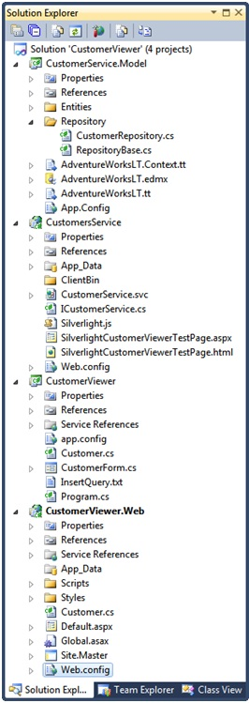
     2. Figure 2
     3. **Solution Explorer**

1. Right-click on **CustomerService.svc** in the **CustomersService** project and select **View in Browser** from the menu. This will start a local WCF server and show a test page.
2. Back in Visual Studio, right-click on the **CustomerViewer.Web** project and select **Set as StartUp Project** from the menu.
3. Run the application by pressing **F5**. The first time the application runs there will be short delay before data is loaded.
4. Once data loads, notice that customers appear in the DropDownList control. Once a customer is selected the details are shown in the form allowing customer data to be updated or deleted using AJAX techniques.
5. Close the application and locate the **CustomerService.Model** project. Double-click the **AdventureWorksLT.edmx** file to see the Entity Framework 4 model that's exposed. The entity model contains a Customer object that is used by the ASP.NET application.
6. Open **CustomerRepository file** in the **Repository** folder and take a moment to look through the code that interacts with the entity model (you might also want to look at the base class named RepositoryBase). This class is responsible for all communication with Entity Framework and acts as a re-useable repository layer in the application.
7. Locate the **CustomerService** project and view **ICustomerService** in the editor to see the operations it exposes. The operations are used to load Customer objects and handle update and delete operations. Some of the operations support RESTful calls. The ASP.NET project currently uses a WCF service proxy object as well as jQuery to communicate with the different service operations. Service calls are forwarded from the service to the CustomerRepository class examined earlier.

**Note**:WCF services work well in environments where data must be exposed to different types of clients without requiring a specific technology or framework. The application shown in this lab uses WCF services to promote data re-use, allow different types of clients to consume data including ASP.NET and jQuery, and provide a standards-compliant way to access data.

1. Locate the **CustomerViewer.Web** project, right-click on **Default.aspx** and select **View Code** from the menu. Take a moment to explore the code and note the following:
   * + A WCF service proxy is used to call a service that supplies customer data
     + If an error occurs loading customer data, a script is sent to the client and used to display an alert
2. Open **Default.aspx** and note the following features:
   * + A stylesheet named **Default.css** is used to add CSS styles into the page
     + A script named **Default.js** is loaded by the page
     + div tags are used to arrange HTML controls in the page
3. Open **Scripts/Default.js** and take a moment to look through the jQuery code (note that the jQuery script is defined in **Site.master**). You'll see the following features:
   * + jQuery selectors are used to locate controls in the DOM and access their values
     + **jQuery** **AJAX** functions such as getJSON are used to communicate with a cross-domain WCF service (JSONP is used in this application since the cross-domain service is trusted)

Exercise 2: Migrating an ASP.NET Application to Silverlight

Now that you've examined the functionality provided by the existing ASP.NET application you'll migrate the application to Silverlight. In this exercise you'll create a new Silverlight project, work with eXtensible Application Markup Language (XAML), create a WCF service proxy to interact with the service and design a user interface that mirrors the existing ASP.NET user interface.

* 1. What benefits do Silverlight and XAML offer to an experienced ASP.NET developer? In a nutshell, XAML provides a declarative way to create user interfaces (much like HTML) and provides a productive and flexible way to layout controls. XAML allows you define the overall layout of controls used in an application without having to know HTML, CSS and JavaScript which can simplify development, minimize code and reduce maintenance costs in many cases. By using XAML you can also avoid cross-browser issues since Silverlight runs in all major browsers on Windows and Macintosh platforms. Postback operations are also eliminated since Silverlight applications run on the client-side.
  2. You can also animate, scale, rotate and even skew objects using XAML which opens up many new avenues for presenting data to end users. You can even completely re-design the look and feel of controls using XAML through the use of styles and templates. If you want to display a list of customers with pictures into a drop-down control you can do it directly without writing custom code. Finally, data bindings between controls and object properties can be defined declaratively in XAML providing a simple yet robust way to bind data in applications. The data binding techniques used in XAML can eliminate a lot of the code typically written to map control properties to object properties which leads to greater productivity and simplified maintenance.
  3. Add a new **Silverlight Application** into the solution by right-clicking the **CustomerViewer** **solution** and selecting **Add 🡪 New Project** from the menu.
  4. From the Installed Templates area on the left of the dialog, pick your desired language (Visual Basic or C#) and select **Silverlight**. Select **Silverlight Application** from the available templates as shown next:
     1. 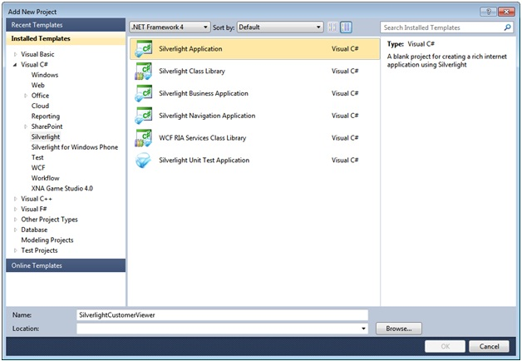
     2. Figure 3
     3. **Add new Project**
  5. Name the project **SilverlightCustomerViewer** and save it within the existing **CustomerViewer** solution folder.
  6. In the next dialog window that appears ensure **<New Web Project>** is selected in the drop-down options and ensure that the project is named **SilverlightCustomerViewer.Web** as shown next. This project will be used to host the Silverlight application in a web page.
     1. 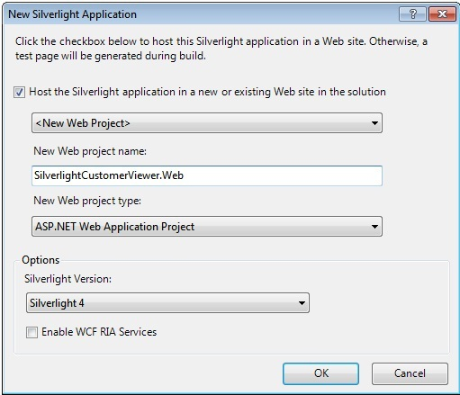
     2. Figure 4
     3. **New Application**
  7. Once the project loads you'll see the Visual Studio editor open in split-view mode with a designer on top and a XAML code editor window on the bottom.
  8. Locate the XAML code editor window and change the **UserControl** element's **d:DesignHeight** and **d:DesignWidth** attributes and add **Width** and **Height** attributes as shown next:
     1. XAML
     2. <UserControl x:Class="SilverlightCustomerViewer.MainPage"  
            xmlns="http://schemas.microsoft.com/winfx/2006/xaml/presentation"  
            xmlns:x="http://schemas.microsoft.com/winfx/2006/xaml"  
            xmlns:d="http://schemas.microsoft.com/expression/blend/2008"  
            xmlns:mc="http://schemas.openxmlformats.org/markup-compatibility/2006"  
            mc:Ignorable="d"  
            **d:DesignHeight="545" d:DesignWidth="550" Width="545" Height="550"**>   
            <Grid x:Name="LayoutRoot" Background="White">   
            </Grid>  
        </UserControl>
     3. **Note:** The d:DesignHeight and d:DesignWidth attributes control the size of the design surface while in design mode. However, they don't have any effect at runtime. The Height and Width attributes constrain the size of the Silverlight screen at runtime. If you don't supply a Height and Width attribute Silverlight will automatically fill the entire area of its container.
  9. Now that the designer has been resized, drag 9 **TextBlock** controls, 1 **ComboBox** control, 5 **TextBox** controls and 2 **Button** controls from the Toolbox onto the designer and arrange them as shown next.
     1. **Note:** The **TextBlock** control is similar to the **Label** control in ASP.NET. The Silverlight Toolkit (available from http://silverlight.codeplex.com) also provides a Label control that can be used in Silverlight applications.
        1. **Tip:** Once you've added a control onto the design surface you can select it and then copy and paste it onto the design surface to add another control of the same type quickly and easily.
     2. 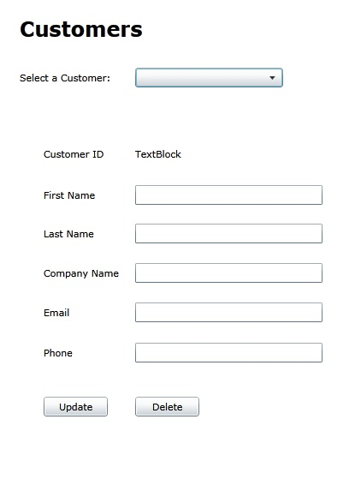
     3. Figure 5
     4. **Customer GUI**
  10. Modify the **Text** property of each **TextBlock** control to match the user interface shown previously (right-click on the control and select **Properties** from the menu).
  11. Modify the **Content** property of each **Button** control to match the user interface.
  12. Right-click on the **ComboBox** control, select **Properties** and change the name of the control to a value of **CustomersComboBox** (you can change the name using the text box at the top of the Properties window as shown next):
      1. 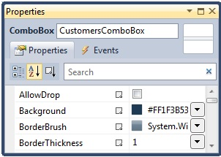
      2. Figure 6
      3. **Properties Window Control Name**
  13. Change the **DisplayMemberPath** property of the **ComboBox** to a value of **FullName**.
      1. **Note:** **DisplayMemberPath** is used to define the property that will be displayed as the **ComboBox** binds to a collection of objects such as Customer objects.
  14. Give the following names to the update and delete buttons in the interface using the Properties window:

|  |  |
| --- | --- |
| Button Content | Button Name |
| Update | UpdateButton |
| Delete | DeleteButton |

* 1. To simulate an HTML frameset tag, drag a **Rectangle** from the Toolbox and drop it on the designer surface.
  2. Right-click on the **Rectangle** and select **Order 🡪 Send to Back** from the menu.
  3. Resize and arrange the Rectangle so that it encompasses the controls as shown next:
     1. 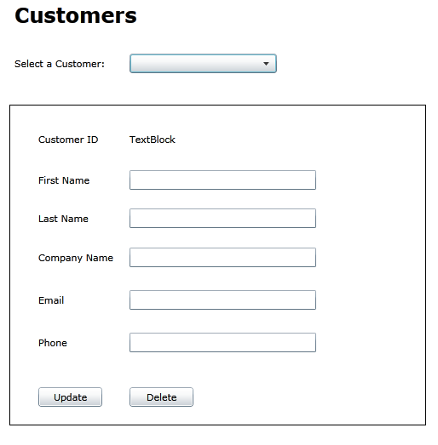
     2. Figure 6
     3. **Customer GUI**
  4. Drag a **Border** control onto the design surface and place it as shown next:
     1. 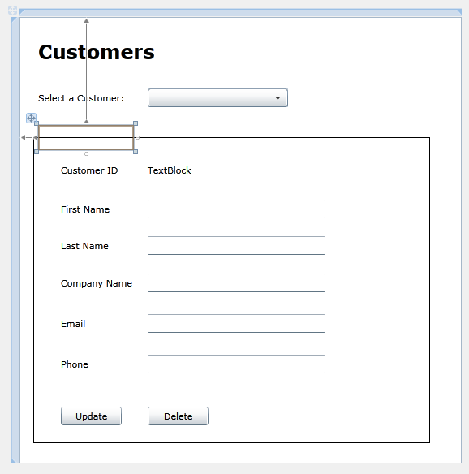
     2. Figure 7
     3. **Customer GUI**
  5. Right-click on the **Border** control in the designer and select **Properties** from the menu.
  6. Change the following properties on the **Border** control:

|  |  |
| --- | --- |
| Property | Value |
| Background | White |
| BorderBrush | White |

* 1. Drag a **TextBlock** control from the Toolbox and drop it **into** the **Border** control (ensure that it's dropped inside of the Border control).
  2. Change the **TextBlock's** **Text** property to a value of **Customer Details**.
  3. Right-click on the Customer Details **TextBlock** and select **Reset Layout 🡪 Size** from the menu.
  4. The user interface should look like the following once done:
     1. 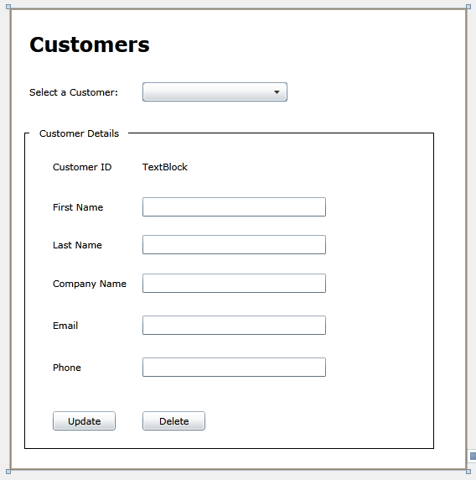
     2. Figure 8
     3. **Customer GUI**

Exercise 3: Calling a WCF Service and Binding Data

* 1. In this exercise you'll create a WCF service proxy that can be used to call an existing WCF service. You'll also use a clientaccesspolicy.xml file to handle cross-domain issues and bind data to controls.
  2. Right-click on the **SilverlightCustomerViewer** project and select **Add Service Reference** from the menu.
  3. Once the **Add Service Reference** dialog appears click the **Discover** button to locate WCF services within the solution.
  4. Click on the icon to the left of **CustomerService.svc** to expand it. Drill-down until you can see the **ICustomerService** contract. Click the contract name and note that it has several service operations available.
  5. In the **Namespace** box supply a name of **CustomerService.Proxies** as shown next:
     1. 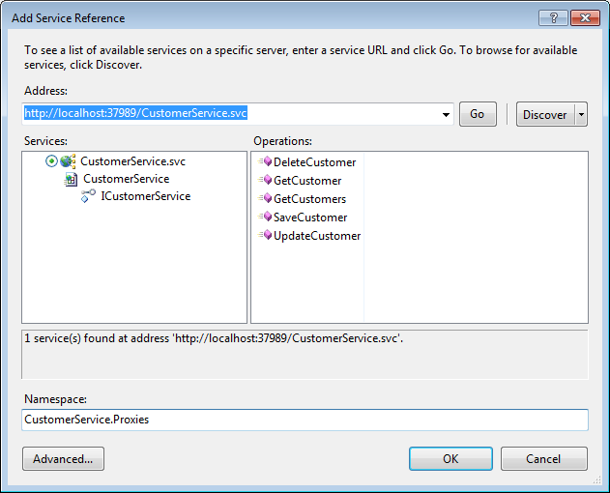
     2. Figure 9
     3. **Add Services**
  6. Click **OK** to create the WCF service proxy.
  7. Add a new **Customer** class into the **SilverlightCustomerViewer** project and change the class's namespace so that it matches with the namespace of the class generated by the WCF proxy:
     1. C#
     2. SilverlightCustomerViewer.CustomerService.Proxies
     3. Visual Basic
     4. CustomerService.Proxies
  8. Add a **FullName** property into the **Customer** class as shown next. Ensure that you mark the class with the **partial** keyword. This property will be displayed by the **ComboBox** control.
     1. C#
     2. public partial class Customer
     3. {
     4. public string FullName
     5. {
     6. get
     7. {
     8. return FirstName + " " + LastName;
     9. }
     10. }
     11. }
     12. Visual Basic
     13. Public Partial Class Customer
     14. Public ReadOnly Property FullName() As String
     15. Get
     16. Return FirstName + " " + LastName
     17. End Get
     18. End Property
     19. End Class
  9. Open the **MainPage.xaml** code-beside file in the editor and import the proxy namespace at the top of the code file:
     1. C#

using SilverlightCustomerViewer.CustomerService.Proxies;

* + 1. Visual Basic
    2. Imports CustomerService.Proxies
  1. Add the following code within the constructor to hook the **Loaded** event to an event handler:
     1. C#
     2. Loaded += MainPage_Loaded;
     3. Visual Basic
     4. AddHandler MainPage.Loaded, MainPage_Loaded
  2. Add a **MainPage_Loaded** method immediately after the constructor with the following code to use the WCF service proxy created earlier and make an asynchronous data request:
     1. C#
     2. void MainPage_Loaded(object sender, RoutedEventArgs e)
     3. {
     4. var proxy = new CustomerServiceClient();
     5. proxy.GetCustomersCompleted += proxy_GetCustomersCompleted;
     6. proxy.GetCustomersAsync();
     7. }
     8. Visual Basic
     9. Sub MainPage_Loaded(sender as Object, e as RoutedEventArgs)
     10. Dim proxy as New CustomerServiceClient()  
          AddHandler proxy.GetCustomersCompleted, proxy_GetCustomersCompleted  
          proxy.GetCustomersAsync()
     11. End Sub
  3. Add the following method and associated code to handle the asynchronous callback that will be made when data from the WCF service is returned to the Silverlight application.
     1. **Note:** Once the WCF service proxy returns data it can be accessed through the GetCustomersCompletedEventArgs object's Result property which is typed as an ObservableCollection of Customer. The collection is assigned to the ItemsSource property of the ComboBox which is similar to the DataSource property found on data controls in ASP.NET and Windows Forms.
     2. C#
     3. void proxy_GetCustomersCompleted(object sender,  
         GetCustomersCompletedEventArgs e)
     4. {
     5. CustomersComboBox.ItemsSource = e.Result;
     6. }
     7. Visual Basic
     8. Visual Basic
     9. Sub proxy_GetCustomersCompleted(sender as Object, _  
         e as GetCustomersCompletedEventArgs)  
         CustomersComboBox.ItemsSource = e.Result  
        End Sub
  4. Back in **MainPage.xaml**, select the **TextBlock** control immediately to the right of Customer ID and select **Properties** from the menu.
  5. Locate the **Text** property and remove any text from it.
  6. Click on the **Text** property's black triangular icon shown next and select **Apply Data Binding…** from the menu:
     1. 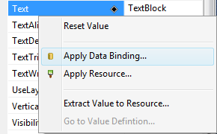
     2. Figure 10

**Apply Data Binding**

* 1. The data binding properties window will appear and open the **Source** area. Click **ElementName** on the left and **CustomersComboBox** on the right to identify the ComboBox as the data binding source as shown next:
     1. 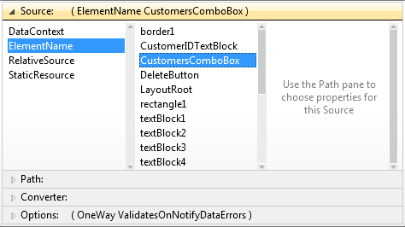
     2. **Figure 11**

**Binding to the wanted property**

* 1. Click on the **Path** area (immediately below the Source area of the data binding window) and select **SelectedItem** from the properties:
     1. 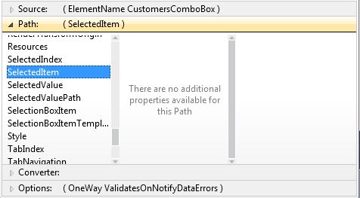
     2. **Figure 12**

**Binding to the wanted property**

* + 1. **Note:** After removing the text from the Text property you won't see the TextBlock control on the designer surface. To get to it within the Properties window you can select the TextBlock in the XAML code or right-click on the designer and select DocumentOutline from the menu. You can then drill-down into the visual tree to select different controls within the designer and access their properties within the Properties window.
  1. Locate the **TextBlock** control modified within the previous steps in the XAML and change the **Text** property value to the following (notice the inclusion of the **CustomerID** property after SelectedItem):
     1. XAML
     2. Text="{Binding ElementName=CustomersComboBox,Path=SelectedItem.**CustomerID**}"
  2. Perform the previous steps to add data bindings to all of the **TextBox** controls in the designer. You'll need to modify the **Text** property of each control within the XAML as in the previous step to specify the appropriate property of the SelectedItem to bind to. The properties that each TextBox should bind to are shown next:

|  |  |
| --- | --- |
| TextBox | Property to BInd |
| First Name | FirstName |
| Last Name | LastName |
| Company | CompanyName |
| Email | EmailAddress |
| Phone | Phone |

* + 1. **Note:** Once you've defined a binding for one TextBox control's Text property using the data binding window it's often faster to copy and paste it within the XAML to the other TextBox controls and then change the property name defined in the binding.
  1. After adding the proper data bindings to the **TextBox** controls take a moment to look through the XAML and notice that each **TextBox** binding has **Mode=TwoWay** added to it. This allows changes to a **TextBox** control to be propagated back to the bound property automatically. An example of a **TwoWay** binding is show next:
     1. XAML
     2. Text="{Binding ElementName=CustomersComboBox,  
         Path=SelectedItem.FirstName,**Mode=TwoWay**}"
  2. Right-click the **SilverlightCustomerViewer.Web** project and set it as the startup project. Set the html page in the project as the startup page by right-clicking the file and selecting **Set As Start Page**.
  3. Press **F5** to compile and run the project and notice that an error occurs once the Silverlight application loads. This is due to a cross-domain call being made from Silverlight to the WCF service. The service uses a different port then the Silverlight host Web project causing a cross-domain exception to be thrown.
  4. To fix the cross-domain issue, rename the existing **clientaccesspolicy.exclude** file in the **CustomersService** project to **clientaccesspolicy.xml**.
  5. Open the **clientaccesspolicy.xml** file in the editor and take a moment to look through the XML. Anytime Silverlight makes a call to a service in a different domain a client access policy file must be in place to successfully talk with the service. This file must be placed at the root of the service application.
  6. Run the application again and notice that data now loads in the **ComboBox** control. Select a customer and data should bind to the appropriate **TextBlock** and **TextBox** controls.
  7. Back in Visual Studio, double-click on both buttons in the designer to create **Click** event handlers.
  8. Add the following code into the **Update** button's click event handler to call the WCF service and pass the updated Customer object:
     1. C#
     2. var proxy = new CustomerServiceClient();
     3. var cust = CustomersComboBox.SelectedItem as Customer;
     4. cust.ChangeTracker.State = ObjectState.Modified;
     5. proxy.SaveCustomerCompleted += (s, args) =>
     6. {
     7. var opStatus = args.Result;
     8. string msg = (opStatus.Status) ? "Customer Updated!" :
     9. "Unable to update Customer: " + opStatus.Message;
     10. MessageBox.Show(msg);
     11. };
     12. proxy.SaveCustomerAsync(cust);
     13. Visual Basic
     14. Dim proxy as New CustomerServiceClient()
     15. Dim cust = CType(CustomersComboBox.SelectedItem, Customer)
     16. cust.ChangeTracker.State = ObjectState.Modified
     17. AddHandler proxy.SaveCustomerCompleted, Sub(s, args)
     18. Dim opStatus = args.Result
     19. Dim msg As String = If(opStatus.Status, "Customer Updated!", _  
          "Unable to update Customer: " + opStatus.Message)
     20. MessageBox.Show(msg)
     21. End Sub
     22. proxy.SaveCustomerAsync(cust)
  9. Add the following code into the **Delete** button's click event handler:
     1. C#
     2. var proxy = new CustomerServiceClient();
     3. var cust = CustomersComboBox.SelectedItem as Customer;
     4. cust.ChangeTracker.State = ObjectState.Deleted;
     5. proxy.SaveCustomerCompleted += (s, args) =>
     6. {
     7. OperationStatus opStatus = args.Result;
     8. if (opStatus.Status)
     9. {
     10. ((ObservableCollection<Customer>)CustomersComboBox.ItemsSource).Remove(cust);
     11. MessageBox.Show("Customer deleted!");
     12. }
     13. else
     14. {
     15. MessageBox.Show("Unable to delete Customer: " + opStatus.Message);
     16. }
     17. };
     18. proxy.SaveCustomerAsync(cust);
     19. Visual Basic
     20. Dim proxy as New CustomerServiceClient()
     21. Dim cust = CType(CustomersComboBox.SelectedItem, Customer)
     22. cust.ChangeTracker.State = ObjectState.Deleted
     23. AddHandler proxy.SaveCustomerCompleted, Sub(s, args)
     24. Dim opStatus As OperationStatus = args.Result
     25. If opStatus.Status Then
     26. CType(CustomersComboBox.ItemsSource, _  
          ObservableCollection(Of Customer)).Remove(cust)
     27. MessageBox.Show("Customer deleted!")
     28. Else
     29. MessageBox.Show("Unable to delete Customer: " + opStatus.Message)
     30. End If
     31. End Sub
     32. proxy.SaveCustomerAsync(cust)
  10. Run the application and test the update and delete functionality.

Summary

* 1. In this exercise you examined an existing ASP.NET application and supporting data access and service layers. You then migrated the existing functionality in the application to Silverlight and satisfied the following requirements:
  + Create a new Silverlight project and associated ASP.NET Web Application project
  + Re-use existing data access and WCF service code
  + Use XAML to define the user interface and emulate the ASP.NET application
  + Handle user interface events
  + Create a WCF service proxy
  + Call the WCF service using the asynchronous programming model
  + Bind data to controls using Silverlight binding syntax
  + Handle update and delete operations and notify the user about the status of the operation
  1. Although the application created in this lab demonstrates how XAML and managed code can be used, other labs will provide additional details about application design practices that can be followed such as the Model-View-ViewModel (MVVM) pattern that you can use to build Silverlight applications.